Are you one of the many homeowners today who:
Has been denied a refinance
Are being foreclosed
Has been told to go late on payments
Are underwater on their home value
Are being given the modification run-around

Would you like to be able to:
Get a proper modification?
Defend against foreclosure?
Negotiate a Short Sale?
Expose Lender violations?
Uncover breaks in Chain of Title?

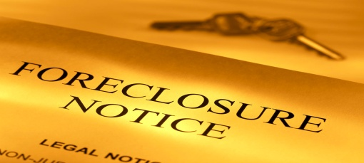

FACT:
Bank of America, and many other major banks, are being sued for violations of consumer’s rights, including mod violations, foreclosure fraud, illegal fabrication of documents, and many more.

FACT:
There are hundreds of Federal and State laws on the books that can help homeowners fight against unscrupulous lenders

FACT:
Homeowners across the country are currently using these laws to get good results from their lenders. A professional advocate that knows how to use the laws to your advantage can make all the difference for you.

As your trusted expert, we know that using at least one of the following three exams as tools in our strategy for you can really help get a good result:
FORENSIC AUDIT
- Looks for violations of RESPA/TILA, Predatory Loan, Predatory Underwriting, and more
- Gives you possible Right to Rescind, CPA claims, Damages Awards, Foreclosure Defense, and more

SECURITIZATION AUDIT
- Uncovers SEC Trust violations, breaks in Chain of Title, Defective Assignments, Path of your Note, path of your Security Instrument, Robo-Signers, Fraud, Forged documents
- Gives you facts to question standing, defense against fraudulent foreclosure, leverage in negotiations
TRUST MOD HISTORY ANALYSIS (TMHA)
- Locates loan in Trust, uncovers Servicer duties, analyzes trust modification history, performance history, payment history
- Uncovers what types of mods have been granted – Rate Reduction, Recapitalization, Term Adjustment, and even Principal Reductions.
- Gives you knowledge of what is being done now, eliminates Lender ability to stall and lie, helps you make a better proposal from the beginning.

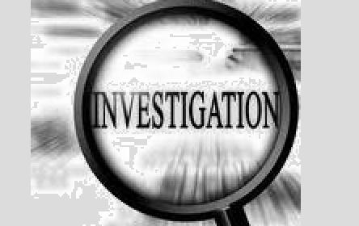
Our auditor has many years experience at uncovering these types of violations, and is qualified to research many different private and government databases to get at the truth for you. A document exam done right gives you new leverage in your discussion with your lender.

Contact us today to see how quickly and inexpensively we can help you put the facts on your side!

